# PRO-C176

SIMPLIFYING JavaScript-

BASICS OF jQuery

# What is our GOAL for this MODULE?

We learned the difference between JavaScript and jQuery and created a simple application to learn about the basics of jQuery.

# What did we ACHIEVE in the class TODAY?

● Understood the difference between JavaScript and jQuery.

● Learned the basics of jQuery.

● Created an online Mad Libs using jQuery.

# Which CONCEPTS/CODING BLOCKS did we cover today?

● jQuery val(), text(), attr(), html(), append(), remove()methods

● jQuery event listeners click and keyup

1. Clone the activity from Activity 1 and run the code.

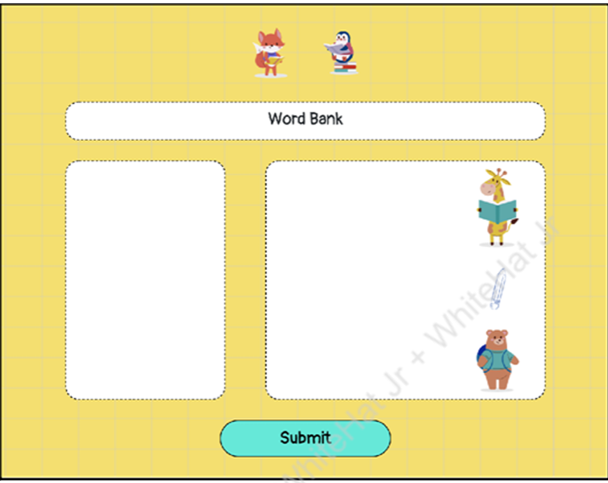

1. Check out the libraries added in index.html.

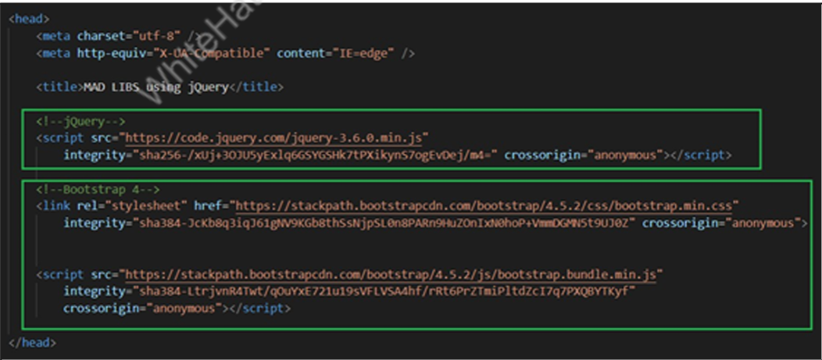

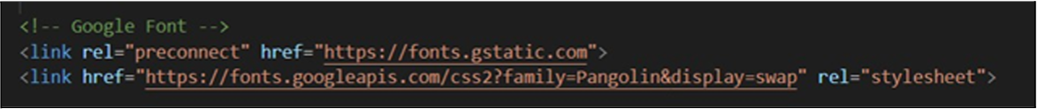

1. Add a document ready event with a function displayStory(),which will show the text content of the story.

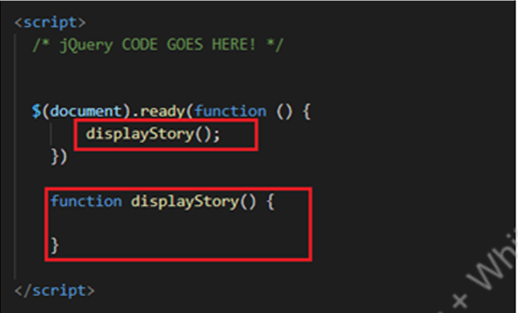

1. Observe the stories array in the boilerplate code with blanks for inputs created using <span> tag.

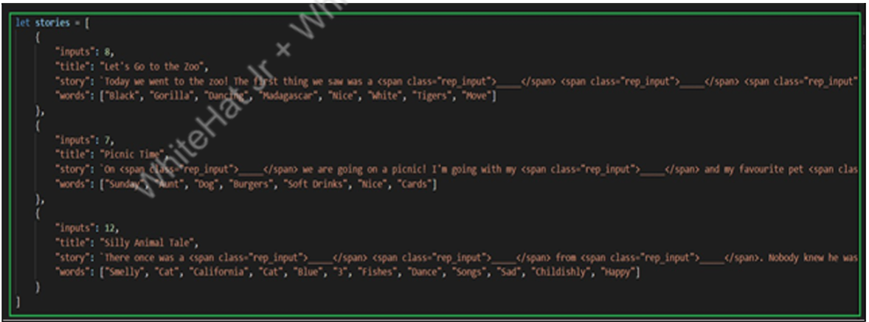

1. Update the displayStory() function to use the html() method to set the story title and the story content and see the output.

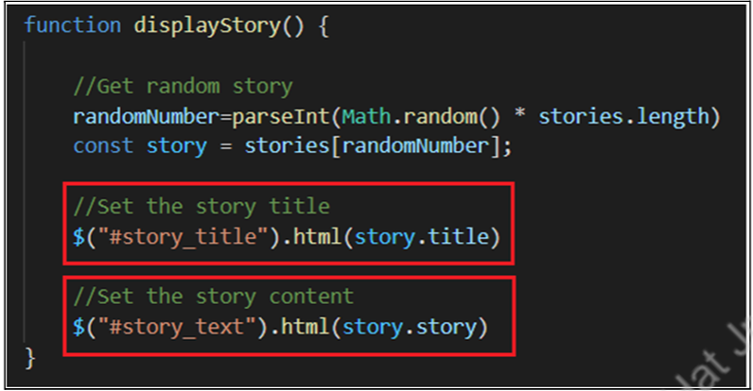

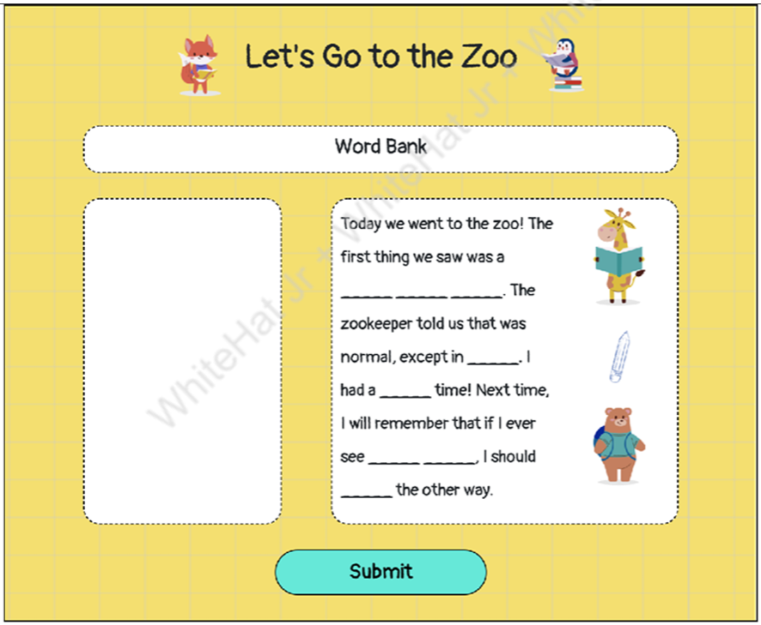

6. Add input boxes for all the blanks(dashes) on the left side of the story content:

● Loop for the number of inputs in a given story.

● Define a<input>type variable and set class, id and placeholder attribute.

● Set the HTML #input_field using jQuery append()method for all the boxes one after the other.

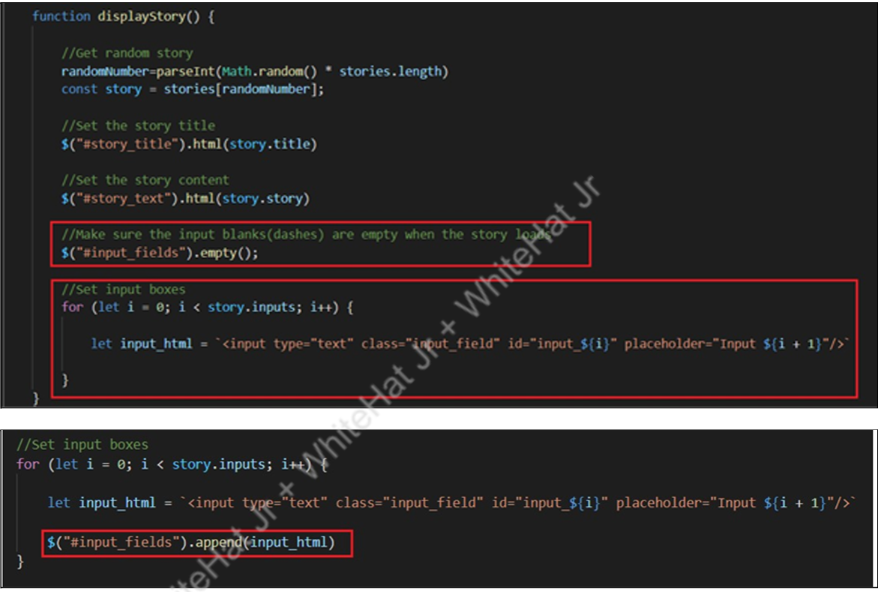

7. Render words (for hints to fill in the blanks) that we have in our stories:

● Loop for the words array in the story.

● Define a<button>type variable and set class attribute.

● Set the HTML#bank_words using jQuery append()method for all the words in the array one after the other.

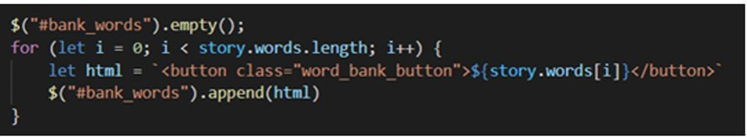

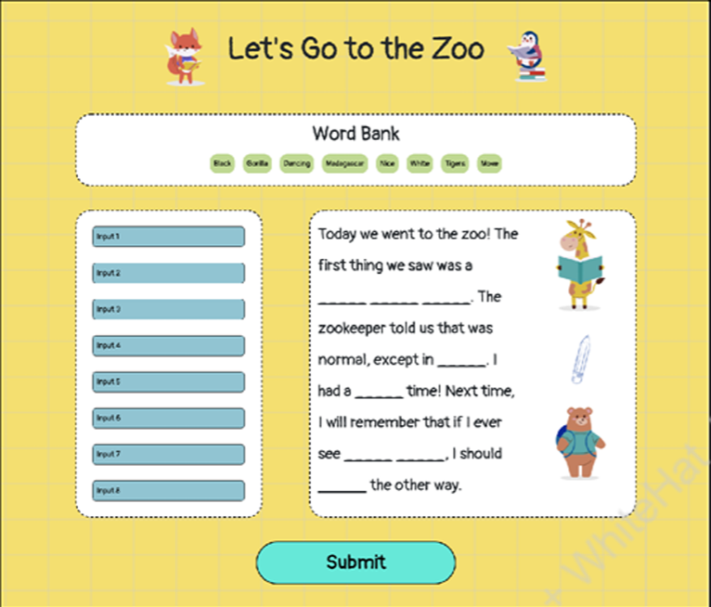

8. Listen to a keyup event on all the input fields by creating a listener for keyup event.

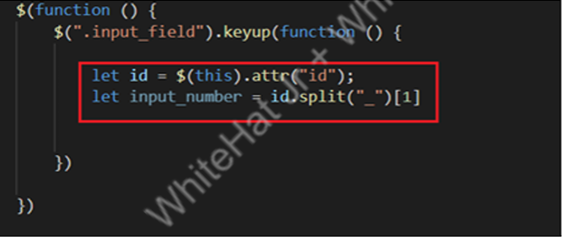

9. Update the HTML with the value of the input field.

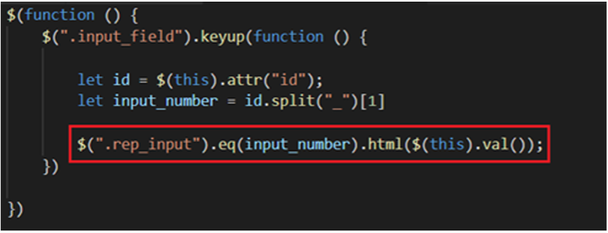

10.Add the click event on the button with id #next_storyand call the displayStory() function inside this listener function.

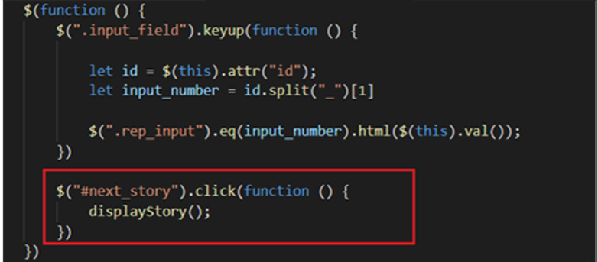

11.Test the output by typing into different input fields and seeing how it is updating the blanks of the story in real time.

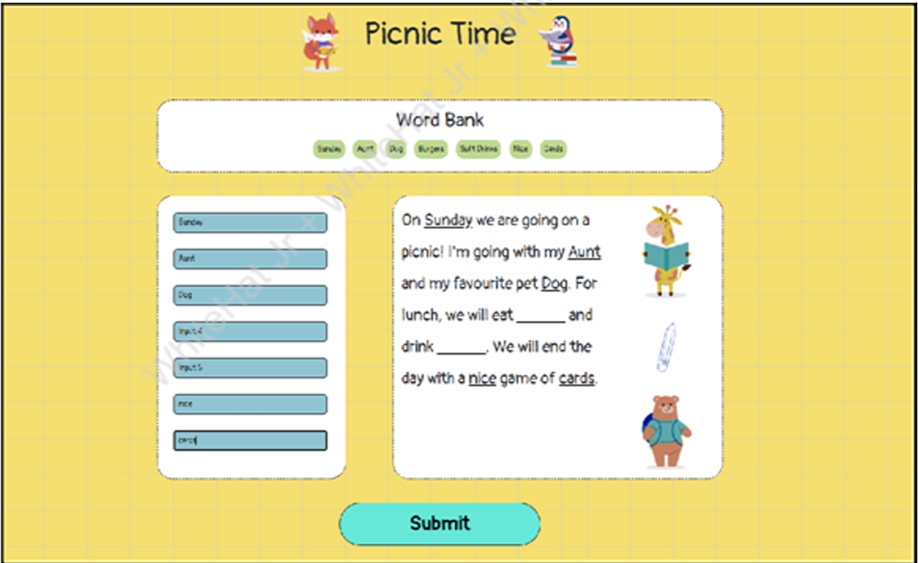

We learned to create a simple application to learn about the basics of jQuery.

# What’s NEXT?

In the next class, we will learn about calling APIs using jQuery ajax() method.

# EXTEND YOUR KNOWLEDGE:

● You can refer to the link below to explore more about AFrame A-Frame

● You can refer to the link below to explore more about jQuery jQuery.